Step 1: Created DB Server using MySQL Workbench and Command Line

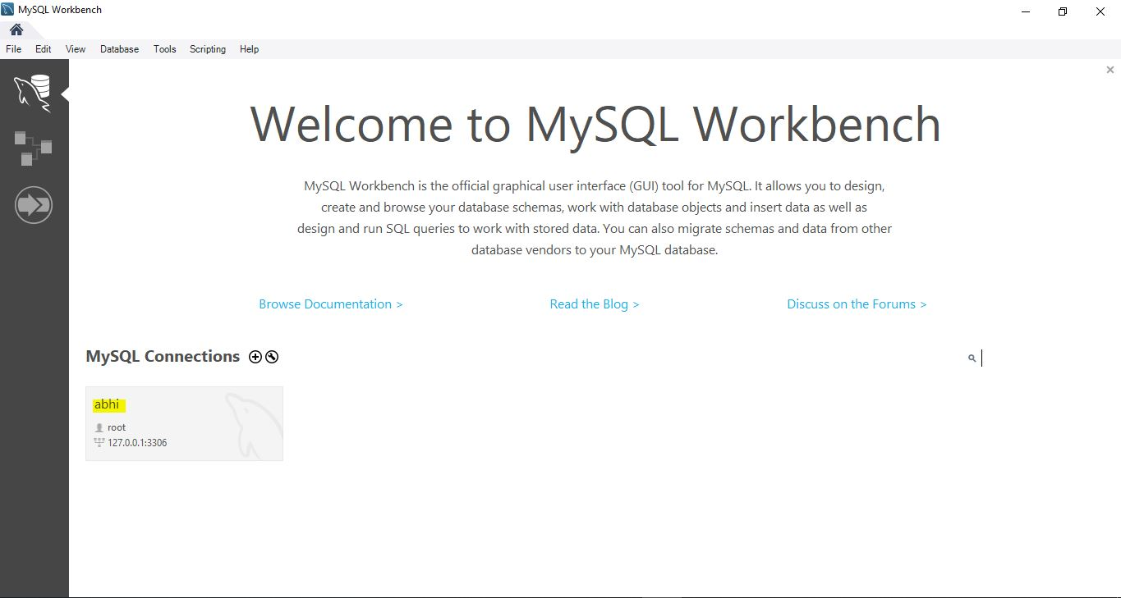

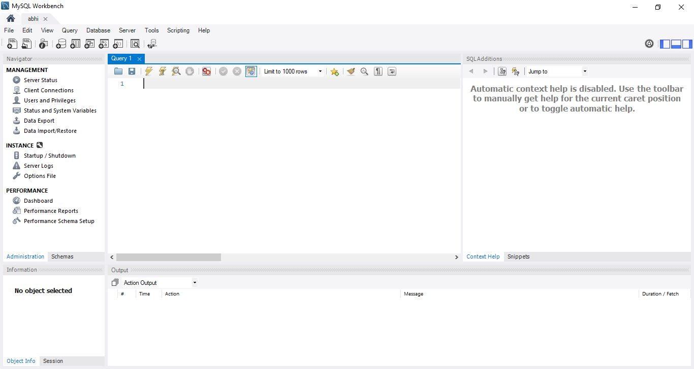

Step 2 : Checked the Status of the server as shown in below pic

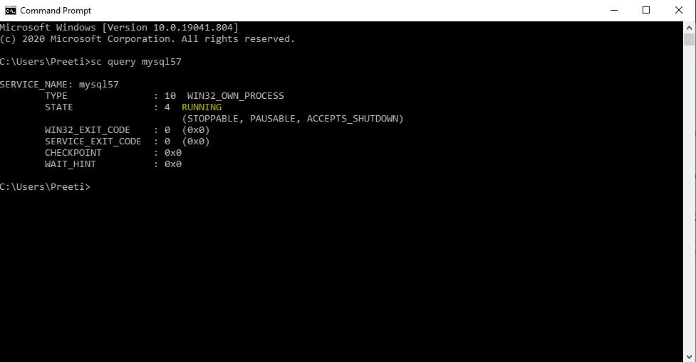

Step 3: Created karkinos database and check connections as shown in below pics:

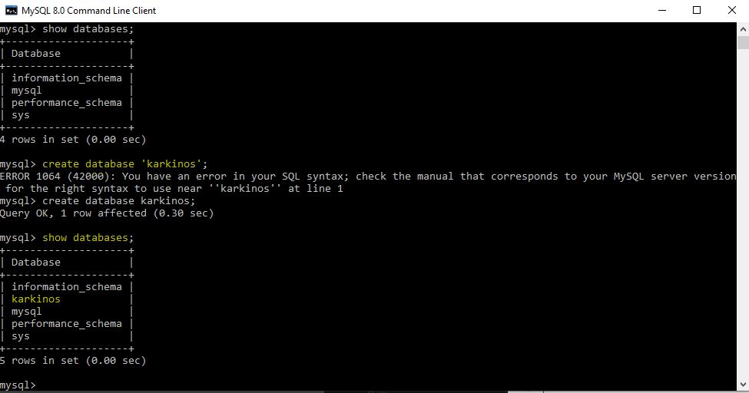

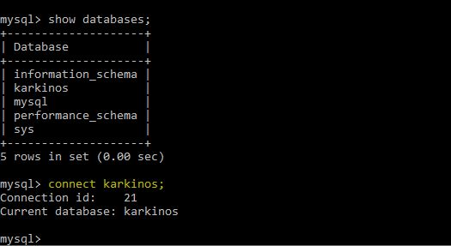

Step 4: Open MySQL workbench and check the schema

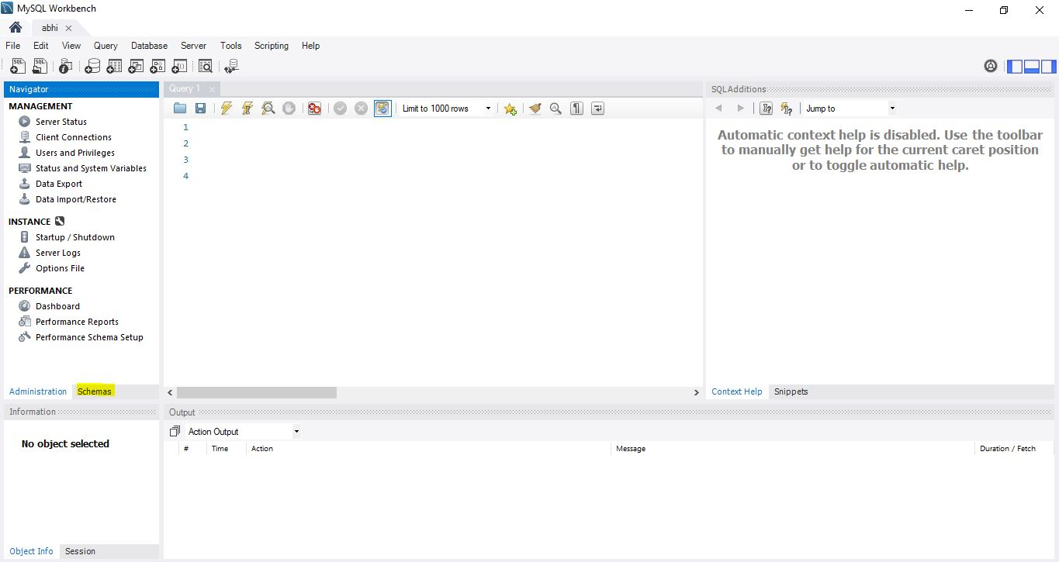

Step 5: Here we can see our karinos database. Opened the connection as shown in below pic

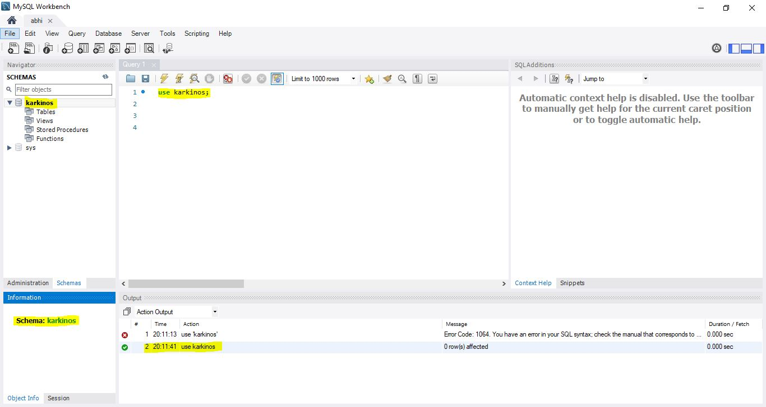

Step 6 :Created Our table Patient in karkinos database.

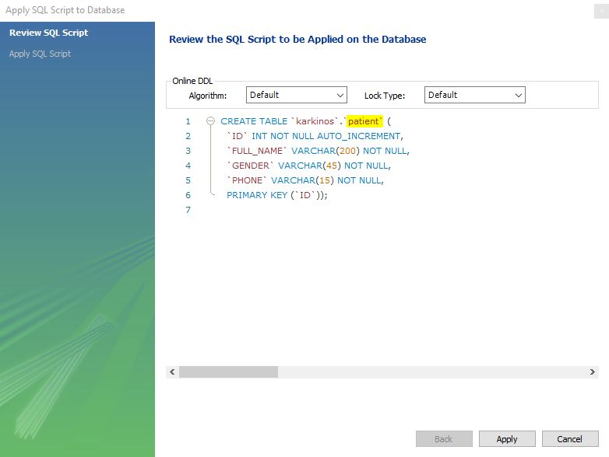

Note: Here in later steps altered the column FULL_NAME to NAME

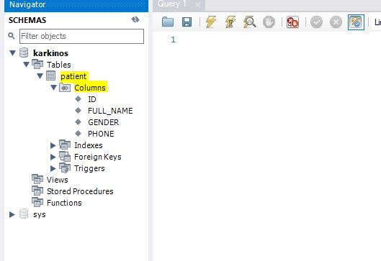

STEP 6: Established the connection of our Database to Eclipse (Eclipse application.properties file)

